Advanced Clinical Pharmacokinetics
Antiarrhythmic Agents and Digoxin
Christina Rose, PharmD, BCPS

By the end of this lecture students should be able to:
- Identify the therapeutic range for lidocaine and digoxin.
- Explain the influence of specific disease states and medications on the disposition of lidocaine and digoxin.
- Recommend an initial loading dose of lidocaine, amiodarone and digoxin.
- Given a patient’s medical history and relevant laboratory values; recommend a
maintenance dose for a patient being started on lidocaine, amiodarone and digoxin.
- Given a patient’s serum concentration of lidocaine and digoxin and clinical outcomes of therapy (response and any side effects), determine if a dose adjustment is indicated.
- If a dose adjustment is indicated, calculate an appropriate loading dose and maintenance dose or dose reduction for the patient.
- Recommend an appropriate monitoring plan for patients on lidocaine, amiodarone and digoxin.
- Given the concentration of a lidocaine and amiodarone infusion, calculate an infusion rate for a specific dose.
- Calculate a DigiFab dose for a patient with digoxin toxicity.

Recommended readings:
- Lidocaine in :Bauer LA. Applied clinical pharmacokinetics. 2nd ed. New York: McGraw Hill Medical;2008. P356-76
- Digoxin in :Bauer LA. Applied clinical pharmacokinetics. 2nd ed. NewYork:McGraw Hill Medical;2008. P301-25

Lidocaine

Pharmacology

Class Ib antiarrhythmic that suppresses automaticity of conduction tissue, by increasing electrical stimulation threshold of ventricle, His-Purkinje system, and spontaneous depolarization of the ventricles during diastole by a direct action on the tissues; blocks both the initiation and conduction of nerve impulses by decreasing the neuronal membrane's permeability to sodium ions, which results in inhibition of depolarization with resultant blockade of conduction

Clinical uses

1. Class IB antiarrhythmic agent
- Used for ventricular arrhythmias
- IV administration only as IV infusion (mg/min)

2. Local anesthetic
- Topical or subcutaneous administration

Pharmacokinetics

1. Absorption
- Bioavailability: 30% (PO) (low), 100% IV and IM

- Know: Salt (HCL)factor : 0.87

2. Distribution
- Two-compartmental model

- Volume of distribution in central compartment (Vc) 0.5 L/kg
- Myocardium responds to lidocaine as though it is located in the Vc

- Volume of distribution for the entire body (V_{area}) 1.5 L/kg

Central volume of distribution (Vc)
V (area)

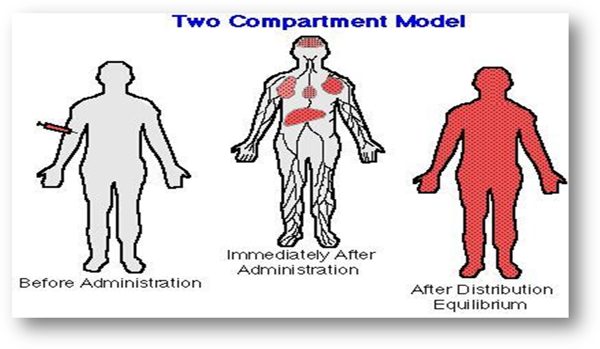

- Affected by disease states:
- Heart failure: Vc= 0.3 L/kg V_{area} = 1 L/kg
- Liver disease: Vc = 0.6 L/kg V_{area} = 2.6 L/kg
- Obese patients: use Ideal body weight for obese patient.

- Protein binding: 70% (to α1-acid glycoprotein)
Binds to Alpha-1 Glycoprotein (not albumin)
If patient has HF or MI → increase in alpha-1 glycoprotein → increase Vd
If pt has liver disease → decrease alpha-1 → decrease Vd

- Loading doses:

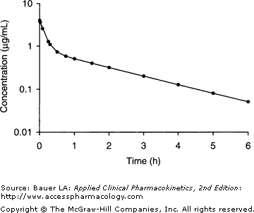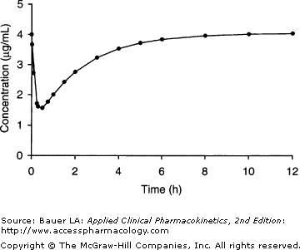

Question 1: A non-obese 70 kg patient with normal organ function is ordered lidocaine for refractory ventricular tachycardia. What loading dose would you recommend? Goal 2 mg/L

1. Calculate volume of distribution (Vc and Vd)
Vc = central compartment (includes heart)
Va = area (other organs)
LD = Cdes * Vd
Vc = 70 * 0.5 = 35L

2. Calculate loading dose
LD * 0.87 salt = 2 mg/L * 35 L
LD = 80 mg

3. Based on what you know about lidocaine’s volume of distribution, why do you think a second loading dose is frequently needed to obtain a desired effect?
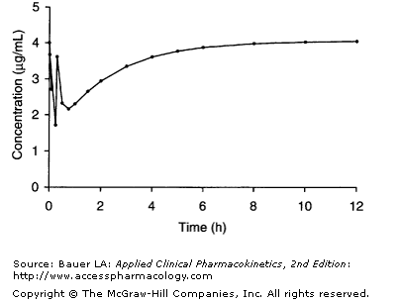Theraputic window > 2 micro/L
give 50% of loading dose: 40 mg IV over 1 min

3. Metabolism
- High hepatic extraction ratio (ER_{H}=70%)
- Dependent upon plasma flow to the liver

- Exclusively metabolized by the liver by CYP 1A2 and 3A4 (both major), to:
  - Monoethylglycinexylidide (MEGX)
    - Active
  - Glycinexylidide (GX)
    - 50% cleared renally
    - Less active then MEGX
    - May contribute to side effects (headache, confusion)

- Clearance:
  - Normal: 10 ml/kg/min
  - Heart failure & cirrhosis: 6 ml/kg/min
  - Severe trauma and critically ill: 6.8 ml/kg/min
  - *Obese patients: clearance correlates with ideal body weight (use IBW for maintenance dose calculations in obese patients)

- Half-life: normal 1-2 hours

4. Excretion
- Less than 5% cleared renally but GX metabolite renally cleared
- No adjustment in renal failure but monitor for signs of toxicity from GX and MEGX accumulation

Dosing guidelines
- Loading dose: Published loading dose guidelines:
- 1 – 1.5 mg/kg (usually 75 – 100 mg)
- Loading doses should be given by a slow IV push (25-50mg/min)
- Maintenance dose: continuous infusion rates at 1-4 mg/min

Monitoring
- Therapeutic range: 1 – 5 mg/L
- When to check a serum concentration:
  - Recurrent arrhythmias
  - Symptoms of ADEs
  - High doses
  - at least 4 – 8 hours after initiation of therapy (at steady-state)

Adverse reactions:
3 – 5 mg/L drowsiness, dizziness, paresthesias, euphoria
6 – 8 mg/L visual disturbances, psychosis, heart block
> 8 mg/L seizures, coma, circulatory collapse

Important formulas
Loading dose = (C_{des)} ( Vc) **
(S)( F)
Ke= Cl_
Varea**

T _{1/2}= (0.693)
Ke

k₀ ₌ (Css ) ( Cl)
(S)(F)

The patient from question 1 is still requiring lidocaine and the physician would like to order a maintenance infusion. What dose would you recommend?

4. Calculate clearance
Cl = 10 ml/kg/min (on equation sheet)
70 kg on previous page
CL = 10 ml/kg/min * 70 kg = 700 ml/min

5. Calculate maintenance infusion dose
infusion range 1-4 mg/min
goal: 2 mg/L
infusion = 2mg/L * 0.7 L/min = 1.7 mg/min * 0.87 salt = 1.5 mg/min
1.6 mg/min

6. The patient’s nurse asks you to calculate the infusion rate of lidocaine (ml/hr). What would you recommend based on the maintenance dose calculated above? The infusion is a 0.4% solution.
24 ml/hr

7. When should a serum concentration be sampled in this patient
calculate t1/2 = ln2 * Varea / CL
Varea = 1.5 * 70 = 105 L
CL = 700 L/min
T1/2 = 104 min
SS is when 3-5 t1/2
4-8 hours (when steady state occurs)

Question 2: The team obtained a serum lidocaine concentration at the time you requested and it returned as 6.5 mg/L at the maintenance dose you recommended. Calculate a new dose that should provide a steady-state concentration of 2mg/L.

1. Calculate new clearance
0.21 L/min

2. Calculate new maintenance infusion rate
1.6 mg/min ---- 6.5 mg/L
x ---- 2 mg/L

maintenance dose = 0.5 mg/min

3. Calculate the infusion rate for the new dose.
Use k0 = Css * CL
0.5 mg/min

